**P2 – Explain using examples how different types of data can be converted and stored in computer systems**

**Introduction**

In this assignment, I will be explaining how different types of data is converted and stored within a system. I will include examples of each one. Data is stored in number of ways to be converted. The types of data that I will be including is the following: text, sound, video, file format and graphic. Below is more detailed:

***Types of data:***

* Representing bit patterns for different types of data e.g. graphics, video, audio and other data;
* Graphics e.g. bitmap (resolution, colour depth, file calculations), vector (objects, properties);
* Sound (compression, sampling resolution, sampling rate, streaming audio, quality);
  + Analogue data; digital data; analogue signals; digital signals;
  + Data conversion e.g. analogue to digital;
* Video (compression, encoding, streaming, quality);
* File formats eg mp3, mp4, wav, avi

**Graphic Images**

Figure 1.1

**Vector Graphics**

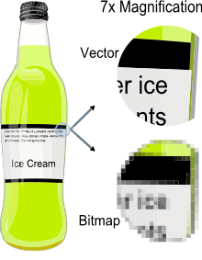Vector is a graphic computer image that it is a scale of quality when it has been enlarged. When it is enlarged, users are focused on the vectors of the image e.g. paths, strokes. It does not lose quality when the image has been enlarged. Referring to the figure 1.1, it shows when you enlarge the image of the bottle. Vector images come out clear whereas Bitmap images does not become clear when it is enlarged. Comparing vector images to ‘JPEG’, ‘GIFs’ and ‘BMP’, it does not contain grid pixels, but it can be different as paths, strokes and curves.

**Bitmap graphics**

As said before, bitmap is a graphic compute image that uses pixels (tiny blocks), because when the image is enlarged, unlike vector graphics, it loses quality. Bitmap graphics can be used on where pixel display is common e.g. CCTV cameras. It is not HD quality, but has pixels like bitmap to be used to create a bitmap display. Referring to figure 1.1, it demonstrates how bitmap image looks like. When it is enlarged, it shows us the pixels. Unlike bitmap, vector images are clear.

**Examples**

An example of how Vector Graphics is that you can tell them by following the rule: 0=black and 1=white. This is shaded in within the table. This is used for bitmap images. It is formatted in a graph to make things easier. It ends up as a letter, which below is C. An example of how they look like is the following:

0000

0111

0111

0000

**Comparisons**

|  |  |  |
| --- | --- | --- |
|  | Vector | Bitmap |
| File size | Small | Large |
| Scaling | Any size | Pixilation occurs |
| File format features | JPEG | PNG |
| Typical uses | Diagrams | Photographs |

**File Format** e.g. JPG, BMP

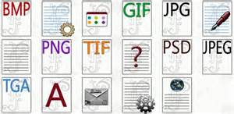A file format is a standard code that is encoded for storage in a computer file. Each standard code are different to each other such as BMP, GIF. They are completely different from each other and have different storage available. They are many file formats and the image below shows how many they could be. They could be more but these are a few.

**Sound**

**Analogue signals**

An analogue signal is any continuous signal which contains time-varying quantities. These analogue signals were introduced in the mid-1990s. An example of analogue signals are speakers. This is a good example as you can increase the sound slowly and constantly. An example that analogue signals were used in the 19th century were old radios. You could continuously change the signal at any time. The analogue signal could be measured by three of the following:

* Light
* Sound
* Temperature

The main advantage of using analogue signals is that they have a higher density than digital signals. They have an infinite amount of signal resolution and they differ from digital signals. Analogue signals are continuous electric signals. Analogue signals have a low cost and are portable but digital signals are not easily portable and are expensive. It can change their amplitude or frequency in response to light, sound and temperature. However, the most major disadvantage of using analogue signals is that it can create a lot of noise. Whereas, analogue signals doesn’t create as much noise as analogue signals do. Referring to Figure 1.1, it shows how analogue signals look like. It flows like a continuous wave.

[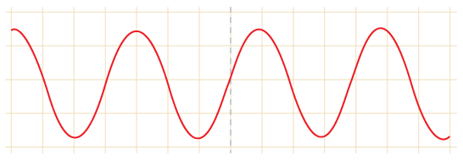](http://www.google.co.uk/url?sa=i&rct=j&q=&esrc=s&frm=1&source=images&cd=&cad=rja&uact=8&docid=6sVpW34c1psqGM&tbnid=H7IdA7nqsj8IZM:&ved=0CAYQjRw&url=http://www.bbc.co.uk/schools/gcsebitesize/design/electronics/logicrev1.shtml&ei=BygoU5TxIqPF0QW_o4DoAQ&bvm=bv.62922401,d.ZG4&psig=AFQjCNFSu-DSumdrqJdh1gNSKdF5MBr7mg&ust=1395227002801251)**Figure 1.1**

**Digital signals**

A digital signals are series of pulses that consist of two states: ON and OFF. A digital broadcast radio transmits digital signals. The waveform for digital signal switches levels from two states (0 and 1). When the digital signal is off, the number 0 represents it. When the digital signal is on, the number 1 represents it by the data. Referring to Figure 1.2, it shows us how digital signal would be data based if it would be inputted into the computer. An example of where digital signal is used is:

* PCs
* PDAs
* Mobile Phones

The main advantage of digital signals over analogue signals is that the precise signal level of the digital signal is not vital. This means that digital signals are accurate when measured. Another advantage is that it costs less electronically than analogue. Another advantage is that it carries more information per second than analogue signal. As a result, the quality is better. This is because if you increase the volume, the quality will stay the game, but analogue, it wouldn’t. However, the disadvantage of using digital signals is that it is complex, not portable and expensive.

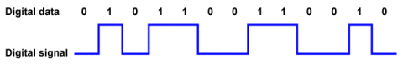**Figure 1.2**

**Comparison**

Digital signals transfer data and in the process, they do not lose the quality once reached the destination. Referring to Figure 1.3, it demonstrates the quality of both signals. Digital regenerates whereas analogue signals has a weak quality throughout the process. Digital signal can be interrupted, ON and OFF button, whereas analogue signal is a continuous signal that can travel far. It is more flexible and it can upgrade to an easier system very quickly and easily. Analogue signals are less tolerant to noise but digital signals are more tolerant to noise. **Figure 1.3**

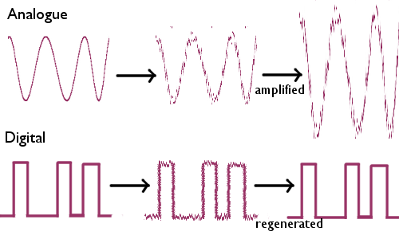

**THE NEED FOR CONVERSION**

* **Noise –** Analogue signals is noisy. It is important because when it converts, it makes less noise. This is one of the reasons why signal conversion is necessary.
* **Compression –** it cannot be compressed. It cannot be stored on a DVD. The only option is to convert the signals.
* **Degradation –** When low analogue levels signal will be directed to other electrically devices. It is better off to convert it as it does not go to any other electrical devices.

**Digital Signal Example & Analogue Signal Example**

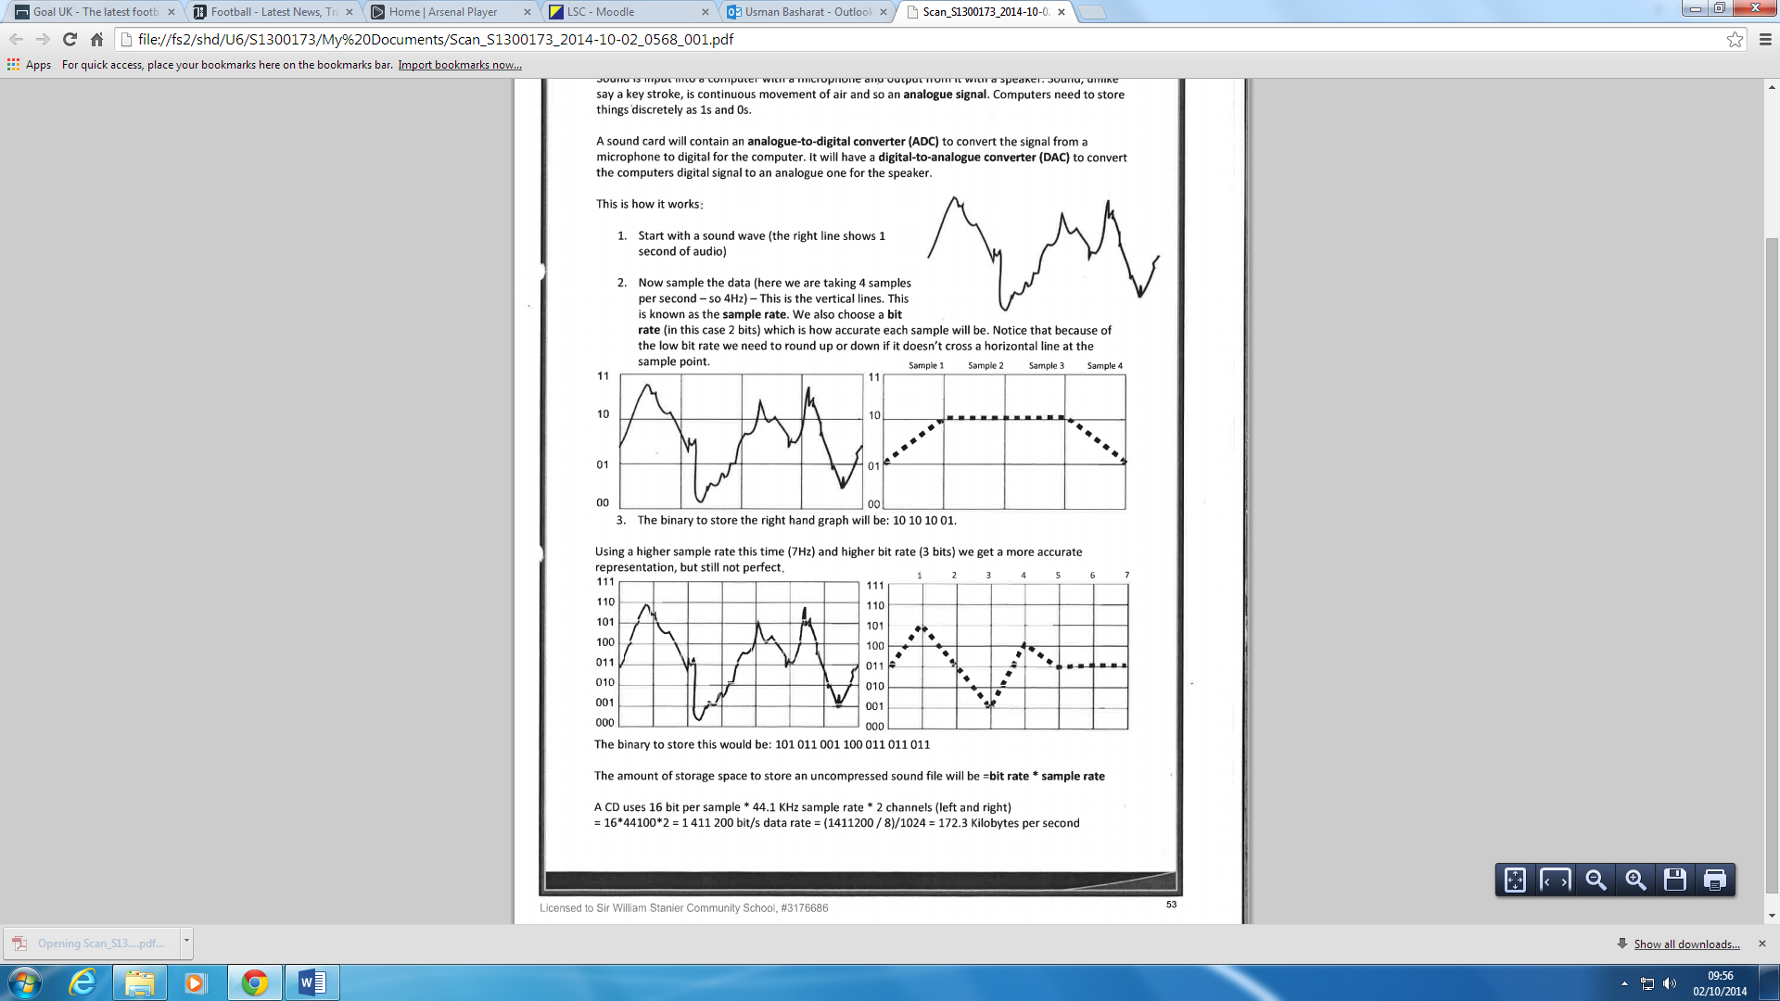

**Image resolution (File Size and Image Quality)**

Image resolution is the detail the image holds. This means any program can help you resize the image in any shape or form. The user can zoom into the image by following the steps:

**IMAGE 🡪 IMAGE SIZE OR** HOLD THE KEYS **ALT+ CTRL+ I**

By following these steps, you can change the resolution of the image. If you want to change the resolution, it measures it dots per inch (DPI). It is important if you want to change the resolution of the image as you can go into detail, take that picture, and add it somewhere. For example, if you use zoom into a house and you zoom into the window, you can use that for another picture and add it there.

**BEFORE AFTER**

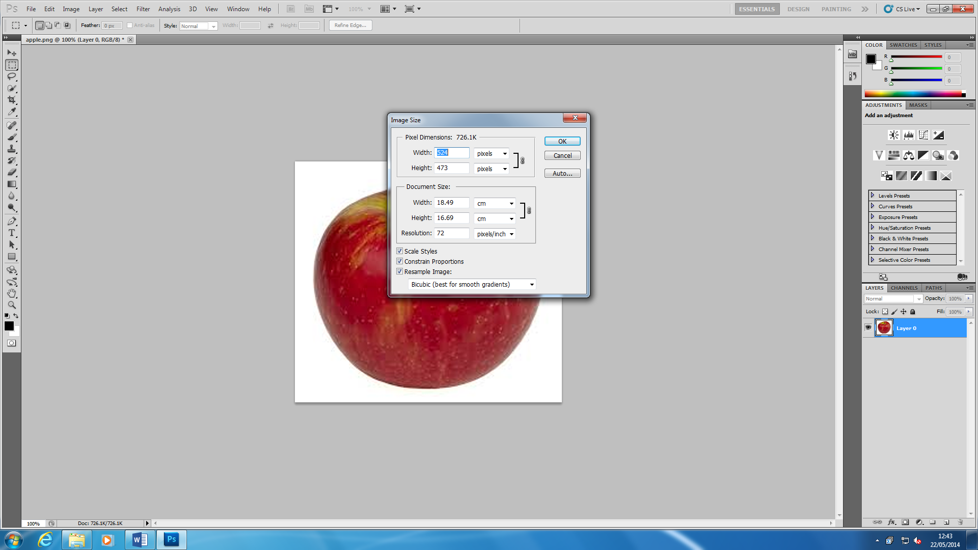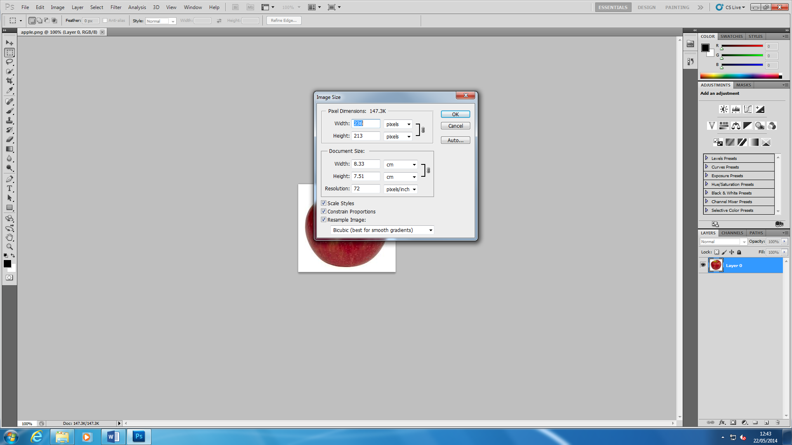

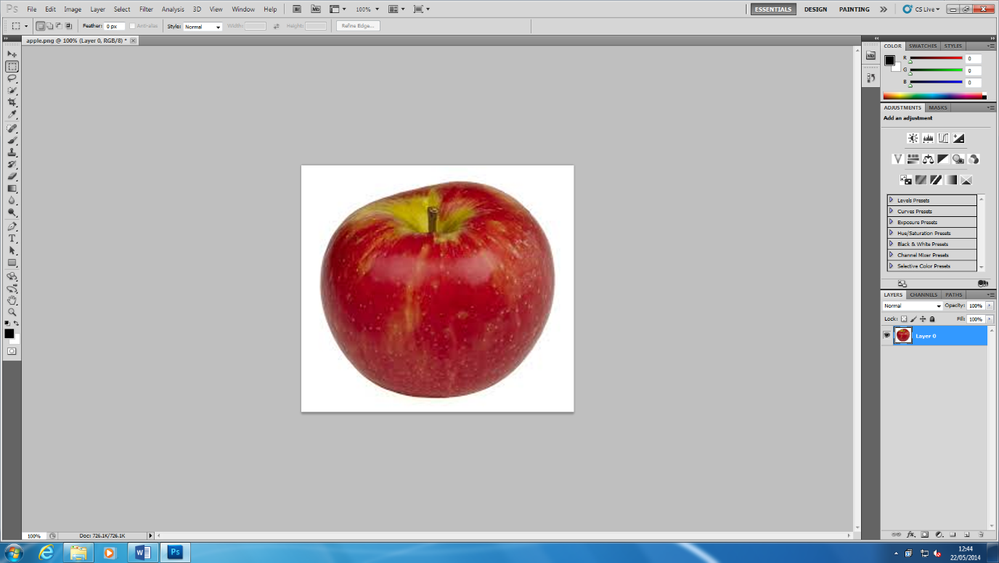These two images came from Adobe Photoshop and I changed the resolution of the image. ‘Before’ image is all the same. I changed it by typing into the ‘Width’ box ‘524’ to zoom the image. If you really want to zoom right into the image, you can type in a higher number for the image resolution to be high. However, if you do increase the image resolution, the quality of the image loses. The higher the image resolution, the more the quality of the image loses. The image below was the result once I had changed the image resolution. The file size will have an effect of the image resolution. Image resolution is measured in DPI (Dots per Inch) and if the quality of the image is increased, the file size will increase. It matters if the quality of the image is quality or not.

**Colour Depth & Image Resolution Example**

Colour depth and image resolution is measured by pixels per unit. Calculations will be needed with the rules to calculate the conversion. The above image would be stored as the following: width = 12 pixel, height = 20 pixels and bit depth = 1 bit. This is represented as a black and white image following the binary code on the right. An example of where this is sued is modern day cameras.

How large, in bytes, will the image shown above be?

Width*height*bit depth + metadata

= 12*20*1+metadata

=240+metadata

=250/8 + metadata

Metadata

= 30bytes+metadata

**2 bytes in width**

**2 bytes in height**

**1 bytes in bit depth**

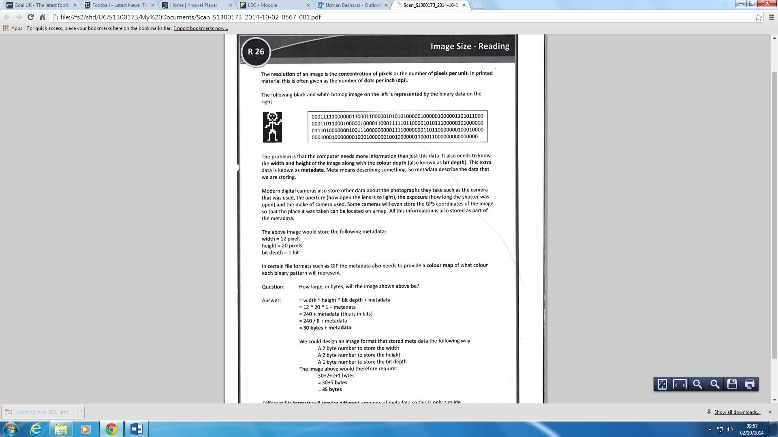 **30+5= 35 bytes**

**File Format** (**File Size and Image Quality)**

A file format is a standard code that is encoded for storage in a computer file. Each standard code are different to each other such as BMP, GIF. They are completely different from each other and have different storage available. They are many file formats and the image below shows how many they could be. They could be more but these are a few. They are the type that can be saved. For example, for Adobe Photoshop, once you have created something, you can save it as a JPEG so you can use it to show others even though you do not have Adobe Photoshop on another system. The image quality stays the same, but the file size of it decreases. It compresses all together for it.

MP3, and MP4 is an audio type of file that saves only audio files. It uses the lossy data compression. This is commonly used to store audio files as well. This is also known as MPEG-2 Audio Layer III. These is used when commonly people download music, it is used for this file type. Common music types are iTunes, and Real Player. WAV stands for Waveform Audio File Format. This stores audios for bitstream. Bitstream format is data that is found in streams. AVI stands for Audio Video Interleaved. This is made by Microsoft that stores both audio and video data. A common example is DVD video format.

**Compression Techniques (Image quality and File size)**

Compression techniques are used in files or image that reduce quality or does not reduce quality when used. The file size changes dramatically. If it is 3000KB, it will change to around 49KB. There is a big difference between the two. Nit does not matter which two, either lossy or lossless, they both are going to change. The two types are called lossy and lossless compression.

**Lossy:**

Lossy compression is when you extract certain amount of information within a file that are not needed. Lossy compression is mostly used in likes of ‘BMP’ (Bitmap Image File). Any image loses quality depending on the compression (low, medium or high). This is used in media such as images. Another file that uses lossy is ‘JPEG’.

**Lossless:**

Lossless is a type of compression which doesn’t lose any data when reducing the amount of data. Lossless clamps all information into a 'more modest packs' or into a littler document measure by inside shorting the information. Case in point if a record size was initially 2(MB) lossless squeezing can decrease the document size into and a large portion of 1(MB) however anyway it relies on upon the document broadening on the off chance that it might be compacted effectively. Lossless packing is exceptionally valuable when using up space or attempting to spare. A great illustration of lossless layering programming might be 'WinZip'. WinZip utilizes lossless squeezing which packs things like projects features, writings, pictures.

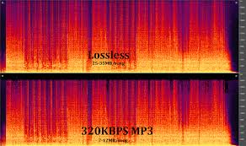

**Colour depth**

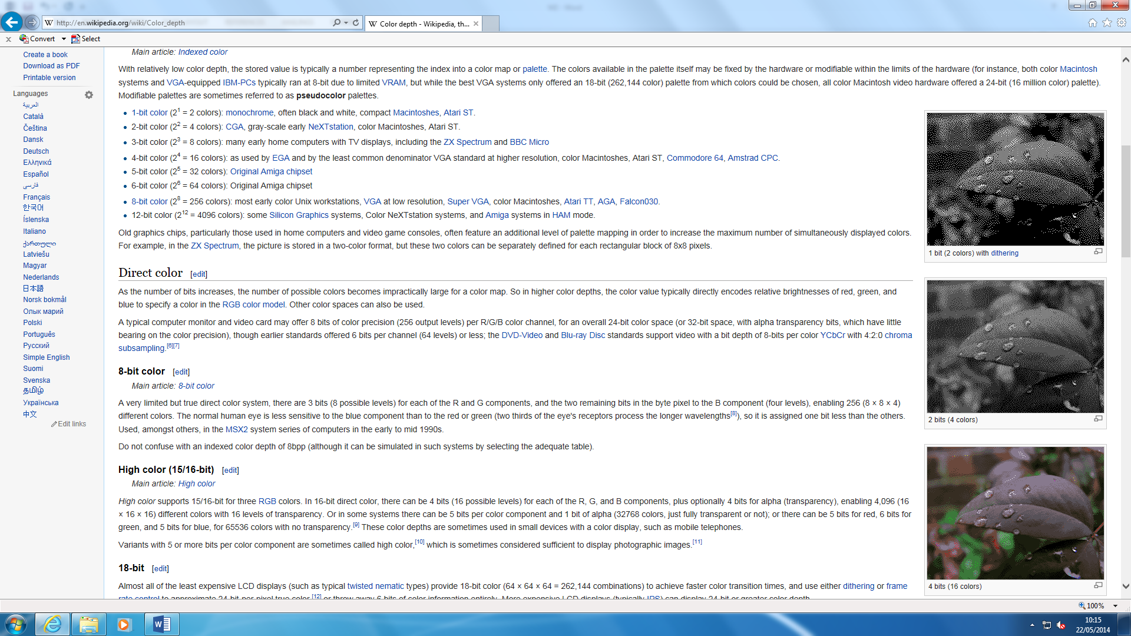Colour depth, also known as bit depth, is either the ‘bit’ used to specify the colour used in a single pixel. The colour depth ranges from 1-bit monochrome to 48-bit deep colour. An image can be present and it can be used to change the colour state e.g. all of the picture would be grey. The depth could be that the ‘grey’ could go ‘light’ or ‘dark’ grey. These are called ‘bits’.

As you can see figure 1.1, it demonstrates the colours that are used on the picture. These range from 1-4 bits and it changes the whole picture by its colour depth. 1 bit is the darkest out of all of them and it goes lighter as the bits increase. Each bit has specific colours that have been inserted. 1 bit has 2 colours. As the bit increases (+1), the colours double. The pattern below shows the how it all works.

* 1 bit = 2 colours
* 2 bit = 4 colours
* 3 bit = 8 colours
* 4 bit = 16 colours

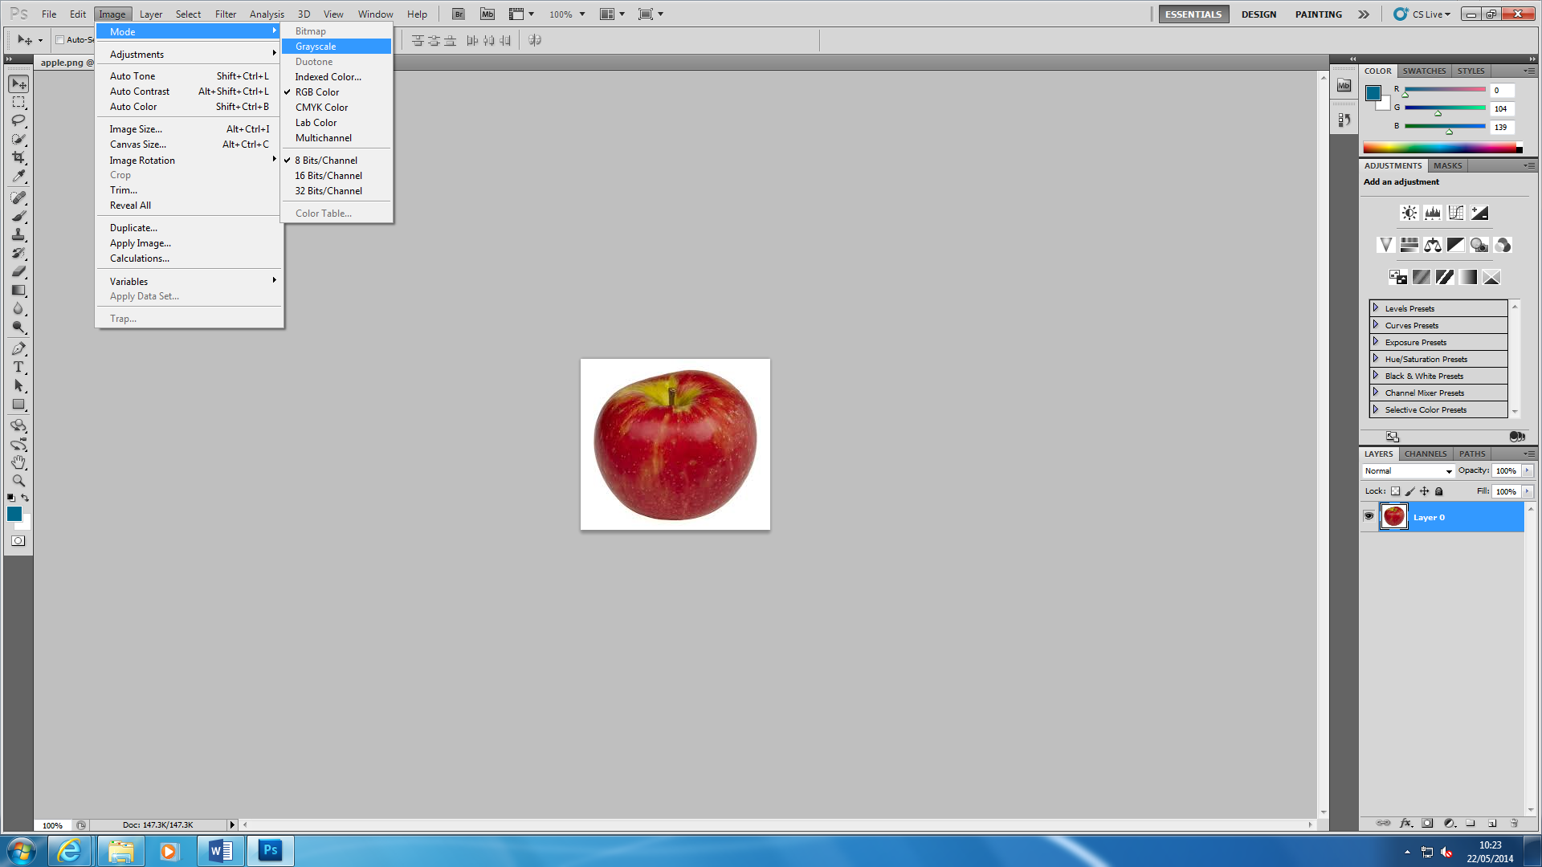

This demonstrates how to change the bits on each image. Each of the image show how many colours you can use. You can ‘Auto Colour’ and it adds more colour to the image. The image below shoes the result of what happens. It detects the bits once you open the image up.

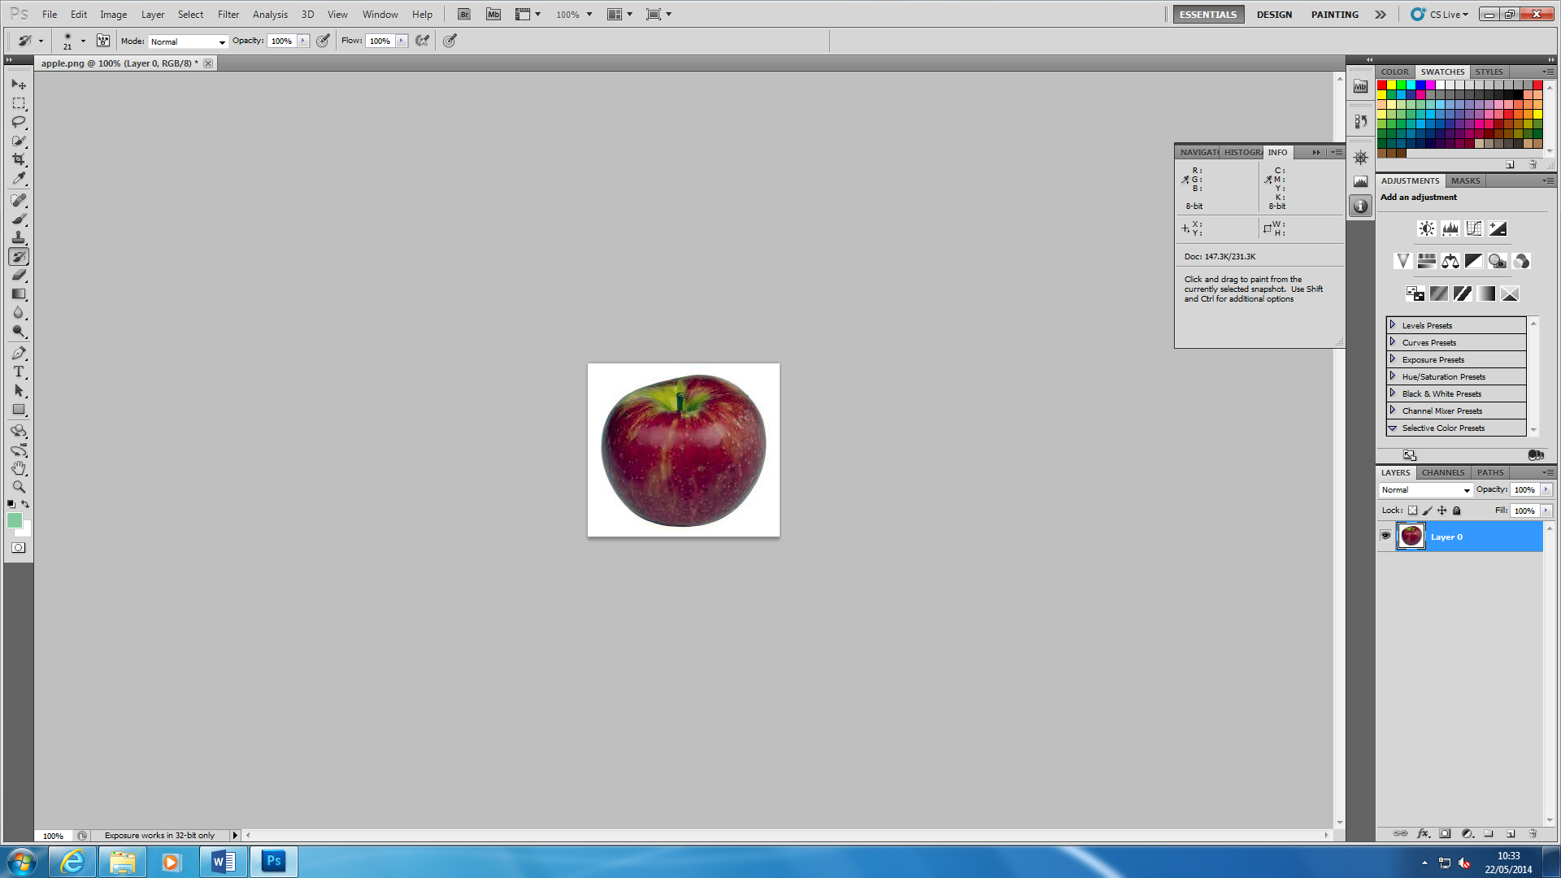

The file size of the colour depth

**Video**

Video has number of qualities for it to convert. A video shows series of static images moving from 24 frames per second. It could go faster to 100 frames per second. Videos are compressed in order to reduce the resolution, reduce the dimensions and reduce the bit rate. These could play the video much faster than it usually does. Resolution in videos are covered from 144p to 1080p. 1080p is HD and it usually runs slow compared to how slow the connection runs. Data loss can be caused by compression. This results in poor quality. In videos, compression is used because there is many binary codes to convert and they are billions to convert. Having billions, they are repeated quite often and compression is used to get rid of them and use the ones that are not repeated a lot.

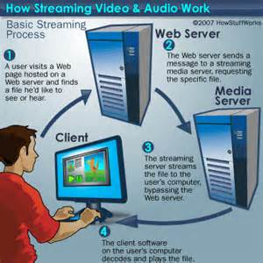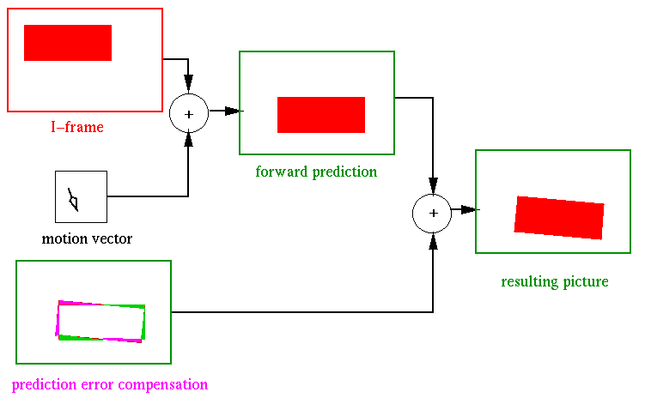

**Streaming**

For videos, streaming is allowed. Streaming allows the user to see the things the person is doing, the same time he is doing it. An example of where streaming is used within the computer is YouTube. They are many sites of where it could be used, but this is the main one and it is very popular. Streaming requires a fast connection. Without a fast connection, the user see the video live because data is travelled very fast from one end to another for it to be complete and ready to go. It is the same process of how a normal video is going, but requires better connection. The picture shows how streaming works. It is like a fast cycle. First step is the user needs to find the server to what he would like to watch fast. The web server sends a message requesting for the client to watch it. Enabling this, the media server sends it to the message for it to be done and decodes it for the user to play the file.